Chapter 2 Exam Overview
2.1a Solve limits graphically
- Evaluate the following expressions using the graph of the function of f(x).

- $\lim_{x→-∞}{f(x)}$
- $\lim_{x→a^{+}}{f\left(x\right)}$
- $\lim_{x→a^{-}}{f(x)}$
- $\lim_{x→a}{f(x)}$
- $f(a)$
- $\lim_{x→b^{+}}{f(x)}$
- $\lim_{x→b^{-}}{f(x)}$
- $\lim_{x→b}{f(x)}$
- $f(b)$
- $\lim_{x→0^{+}}{f\left(x\right)}$
- $\lim_{x→0^{-}}{f\left(x\right)}$
- $\lim_{x→0}{f(x)}$
- $f(0)$
- $\lim_{x→c^{+}}{f(x)}$
- $\lim_{x→c^{-}}{f(x)}$
- $\lim_{x→c}{f(x)}$
- $f(c)$

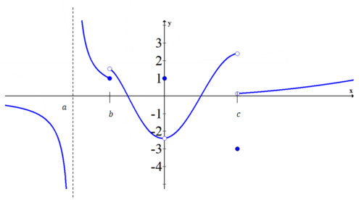

- Evaluate the following expressions using the graph of the function of f(x).

- $\lim_{x→{-1}^{+}}{f\left(x\right)}$
- $\lim_{x→-1^{-}}{f(x)}$
- $\lim_{x→-1}{f(x)}$
- $f(-1)$
- $\lim_{x→0^{+}}{f(x)}$
- $\lim_{x→0^{-}}{f(x)}$
- $\lim_{x→0}{f(x)}$
- $f(0)$
- $\lim_{x→1^{+}}{f\left(x\right)}$
- $\lim_{x→1^{-}}{f\left(x\right)}$
- $\lim_{x→1}{f(x)}$
- $f(1)$
- $\lim_{x→3^{-}}{f(x)}$
- $\lim_{x→3}{f(x)}$
- $f(3)$
- $\lim_{x→-∞}{f(x)}$

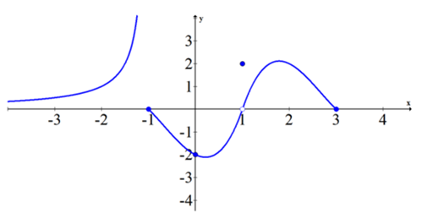

- Identify where everywhere the limit does not exist (DNE) and everywhere the limit exist in the following function.
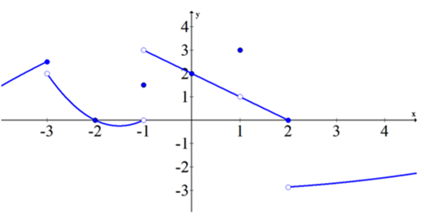
- Use the graph of f(x) below to evaluate the expressions.

  - $\lim_{x→-∞}{f\left(x\right)}$
  - $\lim_{x→∞}{f\left(x\right)}$
  - $\lim_{x→2}{f\left(x\right)}$
  - $\lim_{x→0}{f\left(x\right)}$
  - $f(0)$
  - $f(2)$

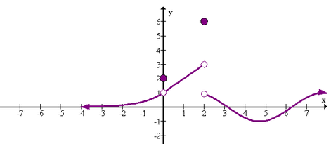
- Use the graph of g(x) below to evaluate the expressions in 7-13.

  - $\lim_{x→-∞}{g\left(x\right)}$
  - $\lim_{x→∞}{g\left(x\right)}$
  - $\lim_{x→2}{g\left(x\right)}$
  - $\lim_{x→0}{g\left(x\right)}$
  - $\lim_{x→4}{g\left(x\right)}$
  - $g(0)$
  - $g(2)$

- Sketch a function $h\left(x\right)$ such that $h\left(2\right)=4$ but $\lim_{x→2}{h\left(x\right)=DNE}.$

- Sketch a function $r\left(x\right)$ such that $r\left(2\right)=4$ but $\lim_{x→2}{r\left(x\right)=-2}.$

2.1b Solve limits numerically
For each of the following limits, determine if you can solve them by substitution (plug-in). Then construct a table that will allow you to see what the limit approaches as x approaches the given value.
- $\lim_{x→2}{\frac{x-2}{x^{2}-x-2}}$
2

- $\lim_{x→2}{\frac{x-2}{x^{2}-4}}$

- $\lim_{x→5}{\frac{x^{3}-125}{x-5}}$
5

- $\lim_{x→0}{\frac{1}{e^{-\frac{1}{x}}+1}}$

- $\lim_{x→0}{\frac{e^{2x}-1}{2x}}$
0

- $\lim_{x→0}{\frac{\sin{2x}}{\sin{5}x}}$

- $\lim_{x→0}{\frac{x^{2}}{1-\cos{x}}}$

- $\lim_{n→∞}{{\left(1+\frac{1}{n}\right)}^{n}}$
1 | 100 | 1000 | 10000

- $\lim_{x→∞}{\frac{3x^{2}-2x+3}{2x^{2}+4}}$

- $\lim_{x→0}{\frac{\sqrt{x+6}-\sqrt{6}}{x}}$

- $\lim_{x→4}{\frac{\frac{x}{x+1}-\frac{4}{5}}{x-4}}$

- $\lim_{x→-∞}{\frac{x}{\left|x\right|}}$

2.1c Solve limits algebraically
Solve the following limits algebraically. Remember the following steps to solving limits:
- Substitute (Plug-in) and Special Trig Functions ($\lim_{x→0}{\frac{\sin{x}}{x}}=1$ and $\lim_{x→}{\frac{\cos{x-1}}{x}=0}$)
- Factor (common factor, factoring, perfect square trinomials, difference of squares, difference/sum of cubes) and cancel (removable discontinuity)
- Conjugate/Common Denominator
- Use Graph and/or Table

- $\lim_{x→6}{(x^{2}-5x-11)}$
- $\lim_{x→0}{(x^{2}+5x)}$
- $\lim_{x→5}{\frac{x+3}{x^{2}-15}}$
- $\lim_{x→3}{\frac{x-3}{x+2}}$
- $\lim_{x→0}{π}$
- $\lim_{x→0}{\frac{2x^{2}-4x}{x}}$
- $\lim_{x→0}{\frac{2x^{3}-4x^{2}}{x^{3}-x^{2}}}$
- $\lim_{x→3}{\frac{x^{2}-2x-3}{x-3}}$
- $\lim_{x→-4}{\frac{x^{2}+6x+8}{x+4}}$
- $\lim_{x→5}{\frac{x^{3}-125}{x-5}}$
- $\lim_{x→\frac{π}{4}}{3\cos{x}}$
- $\lim_{x→0}{\frac{2x}{\cos{x}}}$
- $\lim_{x→0}{4\frac{x}{\sin{2x}}}$
- $\lim_{x→0}{\frac{\sin{5x}}{\sin{3x}}}$
- $\lim_{x→0}{\frac{\tan{7x}}{\sin{5x}}}$
- $\lim_{x→0}{\frac{3}{x}-\frac{3\cos{x}}{x}}$
- $\lim_{x→0}{\frac{(cos{x}-1)}{2x}}$
- $\lim_{x→0}{\frac{\frac{1}{x+4}-\frac{1}{4}}{x}}$
- $\lim_{x→6}{\frac{\frac{1}{x-5}-1}{x-6}}$
- $\lim_{x→4}{\frac{\sqrt{x}-2}{x-4}}$
- $\lim_{x→1}{\frac{\sqrt{x+1}-\sqrt{2}}{x-1}}$
- $\lim_{x→0}{\frac{\left|x\right|}{x}}$
- Let $f\left(x\right)=\left\{\begin{aligned}x^{2}-5, x≤3 \\ x+1, x>3\end{aligned}\right.$ Find (a) $\lim_{x→3^{+}}{f(x)}$ (b) $\lim_{x→3^{-}}{f(x)}$ (c) $\lim_{x→3}{f(x)}$
- Let $f\left(x\right)=\left\{\begin{aligned}x^{2}-5, x≤3 \\ x+2, x>3\end{aligned}\right.$ Find (a) $\lim_{x→3^{+}}{f(x)}$ (b) $\lim_{x→3^{-}}{f(x)}$ (c) $\lim_{x→3}{f(x)}$
- Find the limits at x = -2, x = 0, and x = 1 for the following function:
$$f\left(x\right)=\left\{\begin{aligned} 2; x<-2 \\ -1; x=-2 \\ -x-2x; -2<x≤0 \\ { x}^{2}; 0<x<1 \\ -2; x=1 \\ { x}^{2}; 1<x \end{aligned}\right.$$

Use the properties of limits to solve the following
$\lim_{x→2}{f\left(x\right)=5}$ $\lim_{x→2}{g\left(x\right)=4} \lim_{x→1}{g\left(x\right)=-3} \lim_{x→1}{f\left(x\right)=0}$
- $\lim_{x→2}\left[f\left(x\right)+g\left(x\right)\right]$
- $\lim_{x→2}\left[\frac{f\left(x\right)}{g\left(x\right)}\right]$
- $\lim_{x→1}\left[f\left(x\right)*g\left(x\right)\right]$
- $\lim_{x→1}\left[5f\left(x\right)\right]$
- $\lim_{x→2}\left[f\left(x\right)-g\left(x\right)\right]$
- $\lim_{x→2}\left[\sqrt{f\left(x\right)+g\left(x\right)}\right]$
- $\lim_{x→1}\left[-\frac{3}{g\left(x\right)}\right]$
- $\lim_{x→2}{{\left[g\left(x\right)\right]}^{2}}$
2.2a Limits at Infinity
Limits at Infinity (HA) Horizontal asymptotes occur as x is approaching $∞$($\lim_{x→±∞}{f\left(x\right)=a}$)
Dominance $\frac{x}{x^{2}}=0, \frac{x^{2}}{x}=±∞, \frac{ ax^{3}}{bx^{3}}=\frac{a}{b} exponential>polynomial>logs>trigs$
Infinite Limits (VA) Vertical asymptotes occur when the denominator= 0 ($\lim_{x→a}{f\left(x\right)=±∞}$)
- Graphically: For the graph below, where do vertical and horizontal asymptotes occur?

- For the following limits, first compute the limit algebraically then check it numerically (table) and graphically (graph on the calculator). Where do horizontal and/or vertical asymptotes occur?

- ${\frac{x+2}{x-3}}$

- ${\frac{x+5}{x^{2}+2x-15}}$

- ${\frac{2x^{2}-3x-1}{2x-1}}$

- $\lim_{x→∞}{\frac{10x^{5}-2x^{3}-1}{15x^{5}-3x+2}}$

- $\lim_{x→∞}{\frac{10x-1}{15x^{2}-3x+2}}$

- $\lim_{x→∞}{\frac{\sin{x}}{x}}$

- $\lim_{x→∞}{xe^{-x}}$

- $\lim_{x→∞}{\frac{\ln{x}}{x}}$

- $\lim_{x→∞}{2^{-x}*x^{50}}$

- ${\frac{x^{2}-3x}{3x^{3}-27}}$

2.3 Continuity
Continuity graphically (don’t lift your pencil)
Continuity algebraically – 3 Conditions
- $f\left(x\right)$ exists (function is defined at a = filled in dot/value)
- $\lim_{x→a^{+}}{f\left(x\right)=\lim_{x→a^{-}}{f(x)}}$ (left hand and right hand limits approach each other)
- $f\left(x\right)=\lim_{x→a}{f(x)}$ (the limit in II is equal to I where the function is defined)
Type of Discontinuities
- Removable (hole) – removed when factors cancel out. Occurs when $f(x)≠\lim_{x→}{f(x)}$
- Jump Discontinuity – when a function/line jumps from one y-value to the other. Occurs when $\lim_{x→a^{+}}{f\left(x\right)≠\lim_{x→a^{-}}{f(x)}}$
- Infinite Discontinuity – occurs when denominator = 0 (see V.A.)
Intermediate Value Theorem
Suppose the function g is continuous on the closed interval [a,b]. For any real number d between $f(a)$and $f(b)$there exist a point c between $a$and $b$ such that $f(c) = d$.
- For the following graphs, state where the function is continuous and state the location/type of discontinuities.
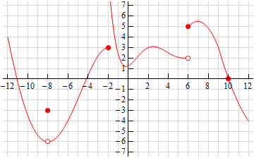
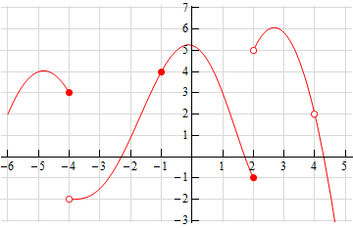

- Determine if the following functions are continuous at the given x-values. If not, what type of discontinuity is occurring?
  - Let f(x) be a function such that $f\left(x\right)=\left\{\begin{aligned}1-2\sin{x}, &x<0 \\ e^{-4x}, &x≥0\end{aligned}\right.$. Is f(x) continuous at x=0?
  - Show that f(x) is continuous at x = 3. $f\left(x\right)=\left\{\begin{aligned}3x+6, &x<3 \\ 5x, &x≥3\end{aligned}\right.$
- Are the following functions continuous?
  - $f\left(x\right)=\left\{\begin{aligned}2x^{3}-1, &x<2 \\ 6x+3, &x≥2\end{aligned}\right.$

  - $f\left(x\right)=\left\{\begin{aligned}5x+7, &x<3 \\ 7x+1, &x>3\end{aligned}\right.$

  - $f\left(x\right)=\left\{\begin{aligned}4x^{2}-2x, &x<3 \\ 10x-1, x=3 \\ 30, &x>3\end{aligned}\right.$

- Find a value k that makes the following functions continuous.
  - $f\left(x\right)=\left\{\begin{aligned}kx^{2}, &x≤4 \\ x+k, &x>4\end{aligned}\right.$

  - $f\left(x\right)=\left\{\begin{aligned}2x+9, &x≤2 \\ \frac{kx}{2}, &x>2\end{aligned}\right.$

  - $f\left(x\right)=\left\{\begin{aligned}kx+5, &x<4 \\ x^{2}-x, &x≥4\end{aligned}\right.$

- Let f be a defined function. Does a limit exist at x=2? Is the function continuous at x=2.
$$f\left(x\right)=\left\{\begin{aligned}\frac{2x^{2}-5x+2}{x-2}, &x≠2 \\ 1, &x=2\end{aligned}\right.$$

- Does $f\left(x\right)=x^{5}-4x^{2}+1$ cross the x-axis between the points [1,2]

- Does the graph of $f\left(x\right)=\left\{\begin{aligned}x^{2}+1, &-3≤x≤0 \\ -1-x^{2}-x^{4}, &0<x≤2\end{aligned}\right.$cross the x-axis between the points [-3,2].
- A particle moves along a continuous function, x(t), where x is the position at time t, such that its position x(2)=5 and x(5)=2. Another particle moves such tht its position is given by h(t) = x(t)-t. Explain why there must be a value for $2<r<5$ such that h(r)=0.

- A scientist measures the height of redwood trees every week. The measurements are taken perpendicular from the base of the tree. The data are shown in the table. Do the data in the table support the conclusion that the tree’s height is 8 feet at some time between $2<t<3$. Justify your answer.

t (years) | 0 | 1 | 2 | 3 | 4
Height (in) | 0 | 2.51 | 6.45 | 9.33 | 10.25

2.4 Average Rate of Change and Tangent Lines
Average rate of change is Slope of Secant Lines: $Avg. Rate= \frac{f\left(x_{2}\right)-f(x_{1})}{x_{2}-x_{1}}=\frac{∆y}{∆x}$
Instantaneous Rate of Change is the Slope of the Tangent Line at a certain point (as a limit approaches a number:
$Ins. Rate:\lim_{h→0}{\frac{f\left(x+h\right)-f(x)}{h}} ($Difference Quotient)
Slope of a Tangent Line at a Point – Use Point-Slope Form $y-y_{1}=m(x-x_{1})$ where m is the slope found from the difference quotient and the point $\left(x_{1},y_{1}\right)$ which is the point where the tangent line is located.

- Find the average rate of change for $f\left(x\right)=2x-4$ from [1,7].

- Find the average rate of change for $f\left(x\right)=3x^{2}-3x+2$ from [-3,3]

- Find the average rate of change for $f\left(x\right)=e^{-x}+2$ from [0,1]

- From the table, find the average rate of change from [4,10]
Time (sec) | 0 | 2 | 4 | 6 | 8 | 10
Height (ft) | 4 | 26 | 38 | 40 | 32 | 14

- Using the graph, calculate the average rate of change from [0,8], [3,8], and [6,8].
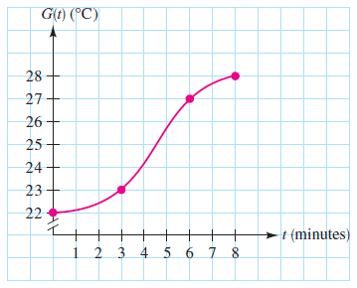
- Find the instantaneous rate of change for the function $f\left(x\right)=2x-3$ at x=1.

- Find the instantaneous rate of change for the function $f\left(x\right)=x^{2}+1$ at x=3.

- What is the slope of the tangent line to the equation $f\left(x\right)=2x^{3}$ at x = 2?

- What is the equation of tangent line to $f\left(x\right)=\sqrt{x+2}$ at the point (2,2)?

- What is the equation of tangent line to $f\left(x\right)=\frac{1}{x}$ at the point x=4?

- What is the equation of tangent line to $f\left(x\right)=3$ at x=3?

