AP Summer Packet- Answers
Complex Fractions

- $\frac{5+a}{a}$ or $\frac{-(a-5)}{a}$

- $\frac{2x}{5x+10}$

- $\frac{4x-12}{5x}$

- $\frac{x^{2}-x-1}{x^{2}+x+1}$

- *note change the problem to the following: $\frac{1-\frac{2x}{3x-4}}{x-\frac{32}{3x-4}}=\frac{2x}{5x+10}$

Function

- $5$

- $17$

- $2t+3$

- $15$

- $8m^{2}+20m+49$

- $2$

- $1$

- $\frac{\sqrt{3}}{2}$

- $15$

- $4x^{2}+12x+9$

- $2x^{6}+3$

- $9$

- $-2$

Intercepts and Points of Intersection
- $x-int: x =\frac{5}{2}→\left(\frac{5}{2},0\right)$ $y-int: y =-5→\left(0,-5\right)$

- $x-int: x =-2 and x=1→\left(-2,0\right) and \left(1,0\right)$ $y-int: y =-2→\left(0,-2\right)$

- $x-int: x =4 , x=-4, and x=0→\left(4,0\right),\left(-4,0\right), and \left(0,0\right)$ $y-int: y =0→\left(0,0\right)$

- $x-int: x =2 , x=-2, and x=0→\left(2,0\right),\left(-2,0\right), and (0,0)$ $y-int: y =0→\left(0,0\right)$
Systems

- $x=3;y=5→(3,5)$

- $x=2;y=2→\left(2,2\right)$
$$x=-1;y=5→\left(-1,5\right)$$

- $x=14;y=-8→\left(14,-8\right)$
$$x=6;y=-8→(6,-8)$$
Add: $x^{2}+y^{2}=4→ x=\sqrt{3};y=1→(\sqrt{3},1)$
$${ x}^{2}=3y x=-\sqrt{3};y=1→(-\sqrt{3},1)$$

Interval Notation

Solution | Interval Notation | Graph
 | $$(-2, 4]$$
$$-1≤x<7$$
$$x≤8$$ | $$(-∞,8]$$

- $\left[\frac{1}{2},∞\right)$
- $\left[-\frac{1}{2},\frac{7}{2}\right)$
- $(30,∞)$
Graph the following problems 30-33 in order to help you see the domain and range of each function.
- Domain: $(-∞,∞)$
Range: $[-5,∞)$

- Domain: $[-3,∞)$
Range: $(-∞,0]$

- Domain: $(-∞,∞)$
Range: $[-3,3]$

- Domain: $(-∞,1)∪(1,∞)$
Range: $\left(-∞,0\right)∪\left(0,∞\right)$

- $f^{-1}\left(x\right)=\frac{1}{2}x-\frac{1}{2}=\frac{x-1}{2}$

- $f^{-1}\left(x\right)=±\sqrt{3x}$
For problems 36 and 37, prove $f\left(g\left(x\right)\right)=g\left(f\left(x\right)\right)=x$
- See above
- See above
Equation of a Line
- $y=3x+5$

- $x=5$

- $y=2$

- $y=\frac{2}{3}x+5$

- $y=\frac{5}{6}x+\frac{19}{3}$

- $y=7$

- $y=-x+3$

- $y=-\frac{3}{2}+3$

Radian and Degree Measure

- a. 150° b. 144° c. 150.687°

- a. $\frac{π}{4}$ b. $\frac{-17π}{180}=-0.296$ c. $\frac{79π}{60}=4.136$

Angles in Standard Position
- For a. – d. be sure to draw your angle from the positive x-axis. Up for positive, down for negative. 180 degrees or π is half of the circle. An example is below:
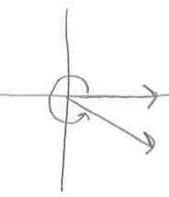
  - $\frac{11π}{6}$

- For a. – d. follow directions from #48. Also be sure to include the length of the sides and hypotenuse. An example is below:
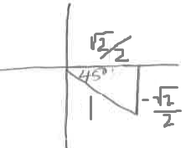
  - $-\frac{π}{4}$

- Answers below

  - 0
  - 0
  - -1
  - 0
  - 1
  - -1

Graphing Trig Functions
Remember sin(x) goes through (0,0) and cos(x) goes through (1,0).
- Find the period of the each of the graphs first by using the equation $\frac{2π}{ω}$ .
- Break graph into fourths to find the max, zero, min, and zero.
- Analyze to see if the graphs reflected or if the amplitude A is affected.
- See if the graph is shifted left/right (inside with the x) and up/down (outside the x).
Example below:
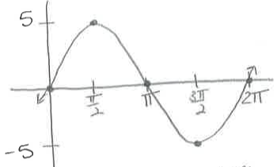
- 1. Period = $\frac{2π}{ω}=\frac{2π}{1}=2π$ for 1 cycle
2. max at $\frac{π}{2}$; zero at π; min at $\frac{3π}{2}$; zero at 2π
3. Amplitude = 1
4. No shift left/right AND up/down

- hint: What does the 2x do to the period? Remember the period is $\frac{2π}{ω}$ .

- hint: What does the – in front do to the graph of cos? What does the $-\frac{π}{4}$ inside with the x do to the graph of cos?

- hint: What does the – 3 outside the graph of cos do to the graph?

- $\frac{7π}{6} ; \frac{11π}{6}$

- $\frac{π}{6} ; \frac{11π}{6}$

- $\frac{π}{8}; \frac{7π}{8}; \frac{9π}{8}; \frac{15π}{8}$

- $\frac{π}{4}; \frac{3π}{4}; \frac{5π}{4}; \frac{7π}{4}$

- $\frac{2π}{3}; \frac{5π}{6}; \frac{5π}{3}; \frac{11π}{6}$

- $\frac{2π}{3}; \frac{4π}{3}$

- $\frac{π}{6}; \frac{5π}{6}; \frac{7π}{6}; \frac{11π}{6}$

- $0; \frac{π}{2}; \frac{3π}{2}$

Inverse Trig Functions

- $-\frac{π}{3}$

- π

- $-\frac{π}{4}$

- $\frac{\sqrt{5}}{2}$

- $\frac{13}{5}$

- $\frac{12}{13}$

- $\frac{7}{8}$

*Hint: #63-66 Draw a triangle with the sides and/or hyptoenuse using Soh Cah Toa. Use Pythagorean Thm. to find the missing side and/or hypotenuse.
Circles and Ellipses
For #67-70 find the center and radius of the circles and/or the center and the semi-major axis a and semi-minor axis b in order to draw the correct ellipse/circle. Two examples are given below

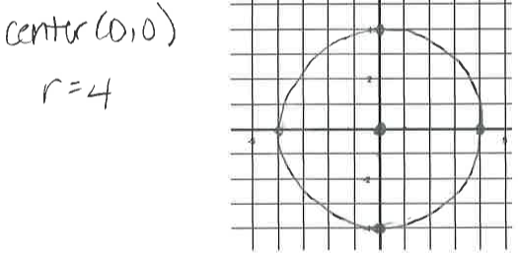

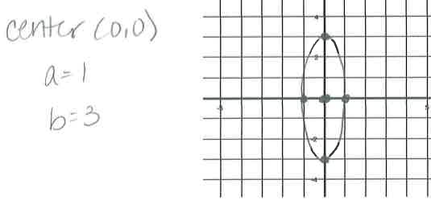
- .

Vertical Asymptotes
- $x=0$
- $x=2 or x=-2$
- $x=0 or x=1$
Horizontal Asymptotes
- Case 1: HA at $y=0$
- Case 2: HA at $y=\frac{5}{-3}$
- Case 3: No HA (there is a slant/oblique asymptote)
Law of Exponents
- $8a^{6}b^{-1}$
- $3a^{\frac{1}{2}}b^{\frac{3}{2}}$
- $\frac{2}{3}a^{2}b^{-1}$
- $ab^{-1}$ hint: Factor the top and bottom. Cancel common factors.
- $a^{-\frac{3}{2}}b$
- $a^{\frac{5}{6}}b$
Law of Logarithms
- $\log_{2}{[5(x+1)}]$
- $\log_{2}{27}$
- 25
- ½
- –x
- $\log_{10}{x^{\frac{4}{3}}}$
Solving Exponential and Logarithmic Equations
- $x=1$
- $-\frac{3}{2}$
- $±\sqrt{8}$
- $±\frac{4}{25}$
Factoring
- $x^{4}\left(x+4\right)\left(x-4\right)$
- $\left(2x+5\right)\left(2x-5\right)\left(x-2\right)$ *hint: factor by grouping – factor out $4x^{2} and 25.$
- $(2x+3)(4x^{2}-6x+9)$ * hint: factor using sum of cubes.
- $\left(x^{2}+1\right)\left(x-1\right)\left(x+1\right)$
Solve for the indicated variable
- $\frac{xbc}{bc-yc-zb}$
- $\frac{V-2bc}{2(b+c)}$

- $\frac{-πh±\sqrt{π^{2}h^{2}-2πA}}{2π} hint:move A to the other side and find a, b, and c to plug into quadratic formula.$

- $\frac{A}{1+xr}$

- $\frac{2x-y}{2y+x}$

- $\frac{π}{(π-1)}$

Solve for x

- $\frac{-3±\sqrt{6}}{2}$

- -3 or ½

- -1/2

Polynomial Division

- $x^{4}-6x^{3} +13x^{2}-26x+45-\frac{89}{x+2}$

- .

SUMMER WORKSHEET GRAPHS HINTS
Here are the graphs of the basic functions found in 1-10. Use a calculator or transformations to graph. I provided hints!
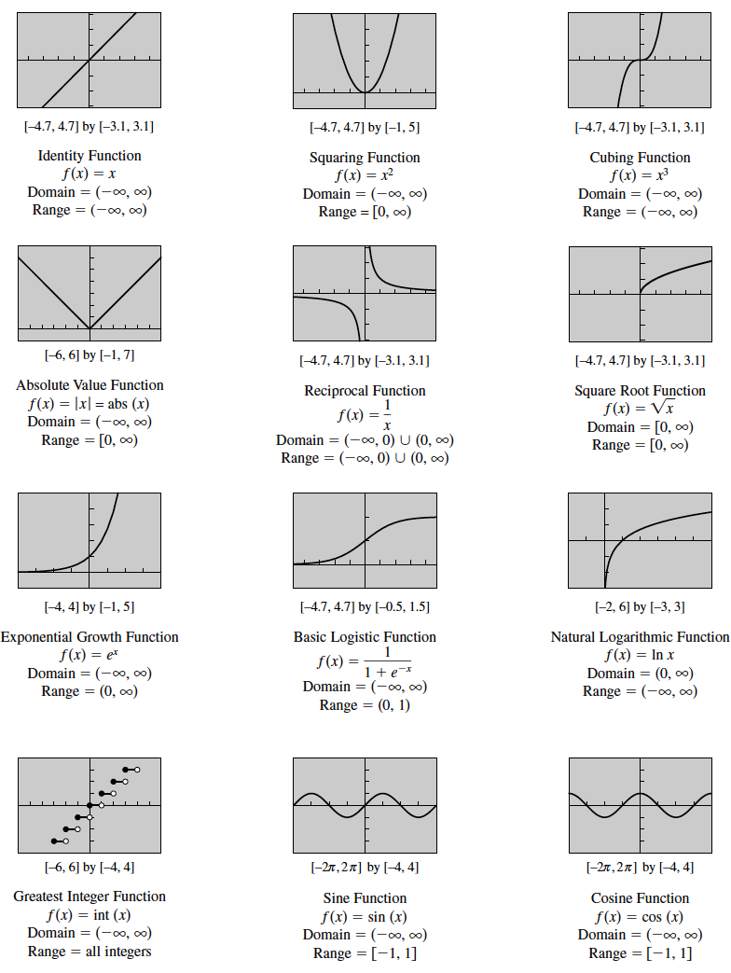
- Sketch each of the following graphs of the parent function transformed.
  - Shift Down 5
  - Shift Up 3
  - Shift Right 10
  - Shift Left 8
  - Vertical Stretch of 4
  - Vertical Compression of ¼
  - Reflection across the x axis
  - Reflection across x-axis; shift left 3; shift up 6
  - Shift left 4; Shift down 8
  - Reflection across x-axis; shift left 1; shift up 4; vertical stretch 2
  - Shift right 6; shift down 6; compress 1/3
  - Reflection across x-axis; shift left 2; shift down 2; vertical stretch 3

- Sketch each of the following graphs of the parent function transformed.
  - Period = $\frac{2π}{ω}=\frac{2π}{2}=π$ for 1 cycle; Amplitude = 1
  - Period = $\frac{2π}{ω}=\frac{2π}{1}=2π$; Amplitude = 1; Shift down 2
  - Period = $\frac{2π}{ω}=\frac{2π}{1}=2π$; Amplitude = 2
  - Period = $\frac{2π}{ω}=\frac{2π}{2}=π$; Amplitude = 2; Shift up 2

  - Period = $\frac{2π}{ω}=\frac{2π}{3}$ for 1 cycle; Amplitude = 1
  - Period = $\frac{2π}{ω}=\frac{2π}{1/2}=4π$; Amplitude = 1
  - Period = $\frac{2π}{ω}=\frac{2π}{1}=2π$; Amplitude = 2; Shift up 2
  - Period = $\frac{2π}{ω}=\frac{2π}{1}=2π$; Amplitude = 2; Reflect over x-axis; Shift down 1

- j
- j
- j
- j
- j
- j

